

SCHOOL OF COMPUTING AND INFORMATICS
BACHELOR OF SCIENCE IN INFORMATION TECHNOLOGY
UNITE TITLE: ADVANCED WEB DESIGN AND DEVELOPMENT
UNITE CODE: BIT3208
PROJECT TITLE: SIMPLE ECOMMERCE
SUBMITTED BY: MINHAJ ABDIKADIR
REG. NO: BSCCS/2024/57588
SUPERVISOR: MR. MICHAEL NYORO

Table of Contents
1.0 LOCALHOST ENVIRONMENT SETUP 2
1.1 Node.js and MySQL Setup 2
1.2 Localhost Testing 3
1.3 Application Pages 3
1.4 Database Connectivity 3
2.0 WEBSITE DESIGN AND PROJECT PLANNING 4
2.1 Wireframe Design 4
2.2 GUI Design 5
2.3 Project Workflow 5
2.4 Technologies Used 5
3.0 SYSTEM FUNCTIONALITIES 6
3.1 User Authentication 6
3.2 Home Page and Product Catalog 6
3.3 Shopping Cart and Checkout 6
4.0 SALES MANAGEMENT 7
4.1 Recording Sales 7
4.2 Sales Records 7
5.0 DATABASE AND VERSION CONTROL 7
5.1 Database Integration 7
5.2 Database connection 8
5.3 GitHub Version Control 8
6.0 CONCLUSION 9
7.0 REFERENCES 9

CLOTHES ECOMMERCE SYSTEM REPORT

1.0 LOCALHOST ENVIRONMENT SETUP

1.1 Node.js and MySQL Setup
The Clothes Ecommerce System was developed using Node.js and Express.js for backend development, with MySQL as the database management system. The development environment was configured by installing Node.js, npm, and MySQL server. Required project dependencies were installed using npm install, and the application was executed using npm start.
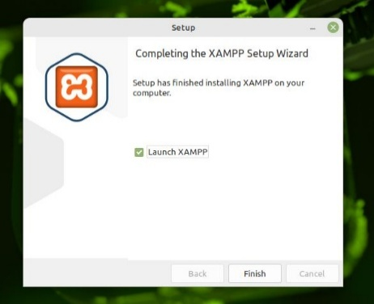
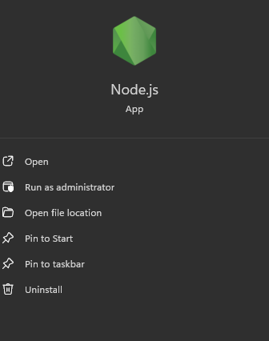

1.2 Localhost Testing
The system was successfully tested on http://localhost:3000, confirming that the Express server was properly configured and capable of rendering application pages.
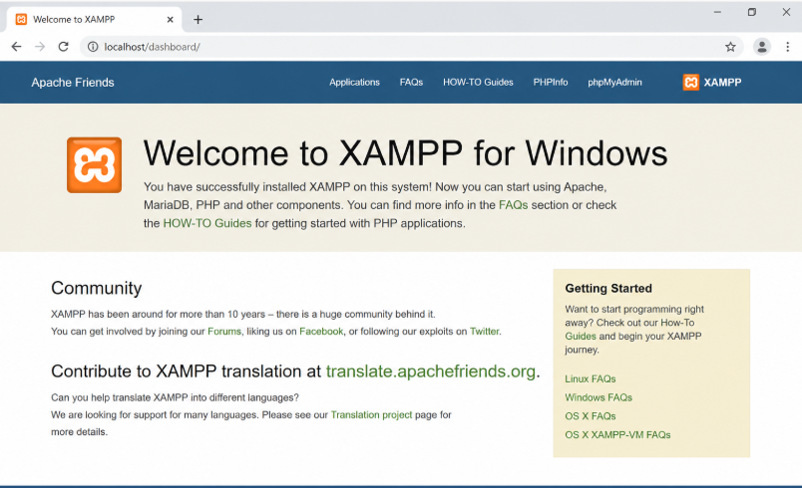

1.3 Application Pages
The project includes key ecommerce pages such as the Home/Product Catalog Page, Product Details Page, Shopping Cart Page, Checkout and Order Confirmation Page, Login and Registration Pages, and the Admin Product Management Panel. These pages were implemented using EJS templates, with static files managed inside the public folder.

1.4 Database Connectivity
Database connectivity was successfully tested by integrating MySQL with the application. The system can retrieve product information, register users, create customer orders, and store purchased items in the database.
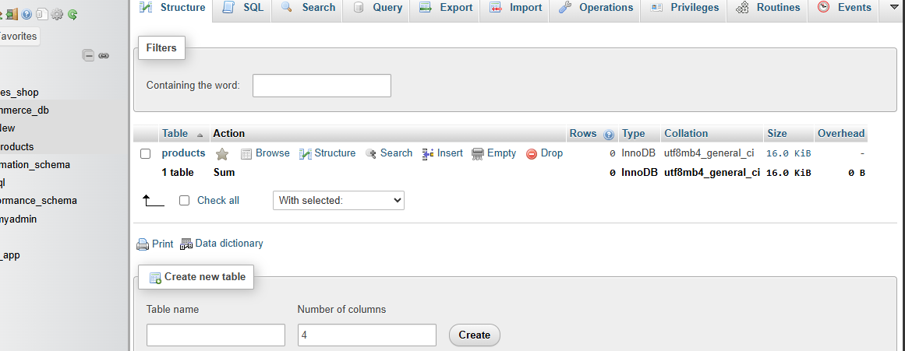

2.0 WEBSITE DESIGN AND PROJECT PLANNING

2.1 Wireframe Design
Basic wireframes were created to outline the homepage layout, product display, shopping cart flow, and administrator dashboard. These designs helped guide the system structure and navigation.


2.2 GUI Design
A clean and responsive user interface was designed to provide an easy shopping experience. The interface focuses on simple navigation, product visibility, cart management, and efficient administrator controls.
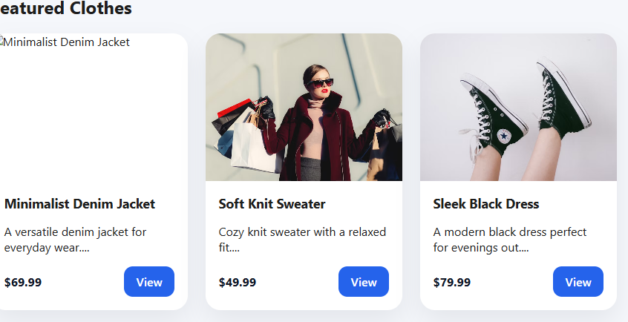

2.3 Project Workflow
The project followed a structured workflow:
- Environment and database setup
- Route and model creation
- User authentication implementation
- Product browsing and cart development
- Admin CRUD functionality
- Checkout and order management
- System testing and debugging

2.4 Technologies Used
The following technologies were used in development:
- HTML, CSS, and JavaScript for frontend development
- Node.js and Express.js for backend server development
- EJS for dynamic page rendering
- MySQL/MariaDB for database management
- bcrypt for password hashing and security
- express-session for user session management
- GitHub for version control and project backup

3.0 SYSTEM FUNCTIONALITIES

3.1 User Authentication
The system includes secure login and registration functionality. Passwords are encrypted using bcrypt, ensuring account security. Registered users can log in, while invalid credentials generate appropriate error messages.
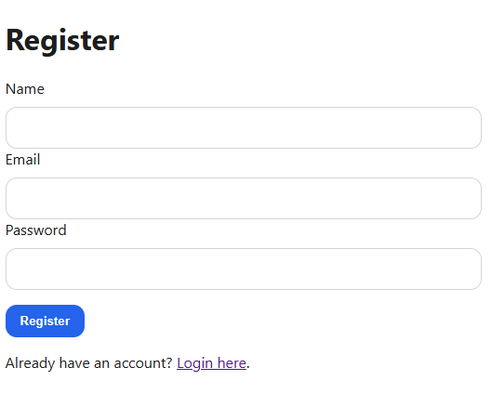

3.2 Home Page and Product Catalog
The homepage displays clothing products retrieved dynamically from the database. Users can browse available products, view product details, add products to the cart, and monitor cart items.

3.3 Shopping Cart and Checkout
Customers can add products to the shopping cart and complete purchases through checkout. Once checkout is successful, order details are saved in the database, purchased items are recorded, the cart session is cleared, and an order confirmation page is displayed.
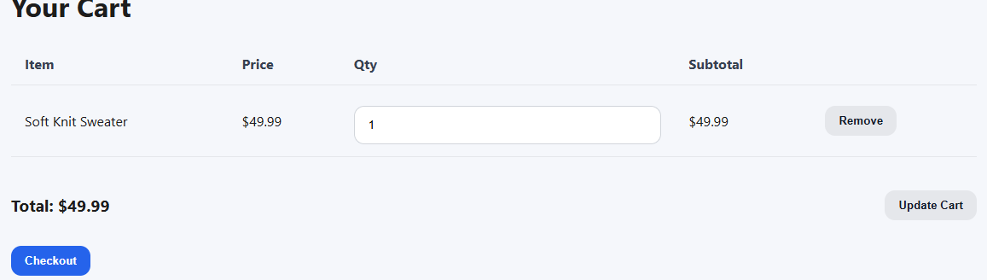

4.0 SALES MANAGEMENT

4.1 Recording Sales
When a customer completes checkout, the system automatically creates an order record and stores purchased products in the database.


4.2 Sales Records
The system maintains sales records, including customer information, order total amount, purchase date, and ordered products.
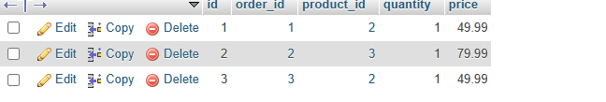

5.0 DATABASE AND VERSION CONTROL

5.1 Database Integration
The application connects to MySQL using a dedicated database connection module. Queries are executed securely using mysql2 with parameterized statements to reduce SQL injection risks.
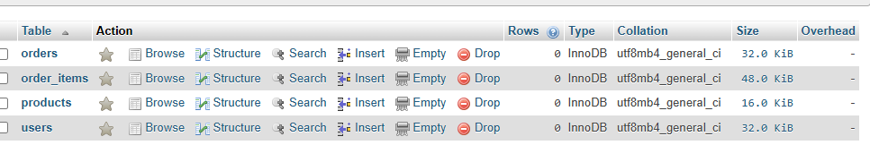

5.2 Database connection
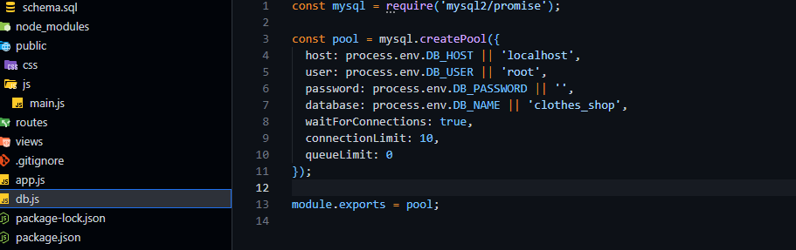
The system database contains the following tables:
- users – Stores registered user information
- products – Stores clothing inventory details
- orders – Stores completed customer purchases
- order_items – Stores purchased products per order

5.3 GitHub Version Control
GitHub was used to manage source code, track project progress, and maintain backups throughout development.
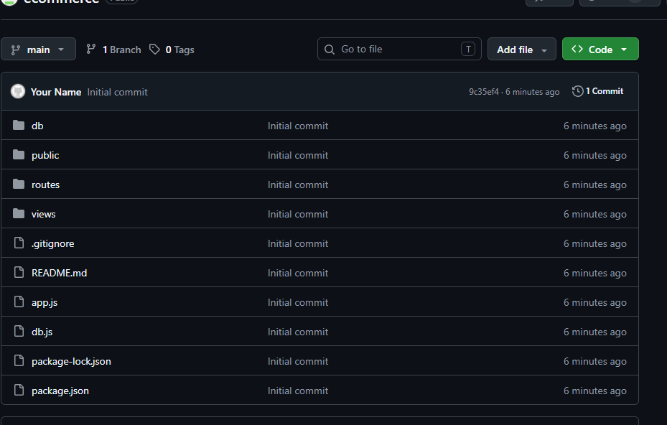
https://github.com/minhajdakane932-oss/ecommerce

6.0 CONCLUSION
The Clothes Ecommerce System successfully demonstrates a complete ecommerce web application using Node.js, Express.js, and MySQL. The system provides secure authentication, dynamic product browsing, shopping cart functionality, order processing, inventory management, and database integration. The project successfully meets the objectives of a modern web-based ecommerce platform.

7.0 REFERENCES
HTML Documentation: https://www.tutorialspoint.com/html/index.htm
CSS Documentation: https://www.tutorialspoint.com/css/index.htm
JavaScript Documentation: https://www.tutorialspoint.com/javascript/index.htm
Node.js Documentation: https://nodejs.org/en/docs
Express.js Documentation: https://expressjs.com/
MySQL Learning: https://www.mysqltutorial.org/
Git & GitHub Learning: https://skills.github.com/

